I have finished developing my tables, and I have started importing a large set of data entries into my tables which has taken up most of the time I have spent working on the project as of now. Here are some screenshots of the tables I have made and some of the data I have entered. I have not yet started working on my front end as I have been working solely on my tables and setting up the data to start working with.

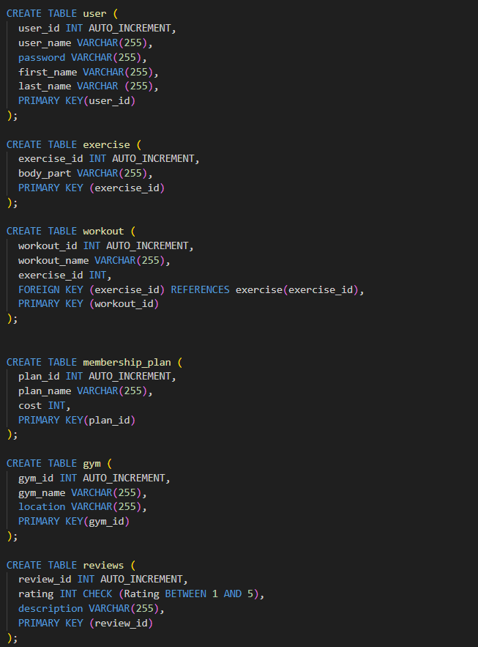

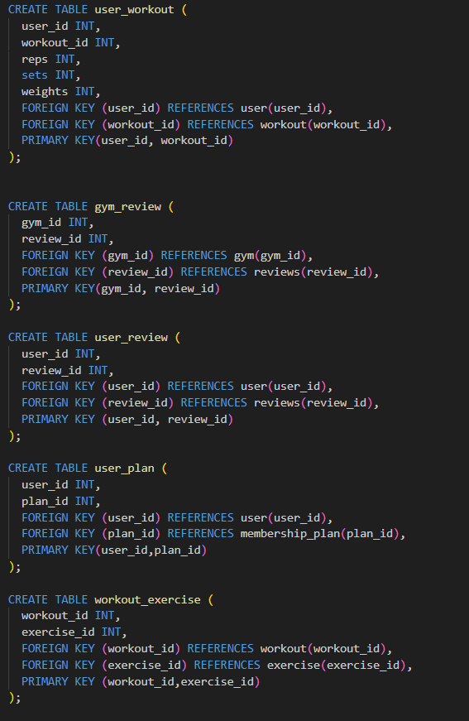

Here are some of the inserts I have been working on, trying to make a wide variety of workouts a user can choose from and the body part they will be focusing during that workout.

